Measuring the Quality of Life

in Diabetic patients

Summary
Quality of life is a significant role in physical and mental well-being, which measured as physical and social functioning, and perceived physical and mental well-being. Living with diabetes and managing it can be cause of stress, anxiety and depression and it affect blood glucose levels but, it can be managed by the diet planning, medicine, exercising, enough sleep and many more. This survey mainly focuses on quality of life in diabetes patients which includes quality of life, factors such as physical activity, mental status, and social well being of patients. It includes how diabetes affect health of patients may lead to cause of stress, anxiety and, depending on daily life. Further information about improving patients’ health status and ability to control their disease results in improved quality of life. Quality of life and diabetes survey points consider psychological predictors, gender, complications, type of diabetes, treatment regimen, other chronic diseases, and the end possibility of improving quality of life in diabetes. It concluded that diabetes plays major role in quality of life. There are main complications with the diabetes but, with the good take care, daily plan and medicine can be reduce complications and improve quality of life.

Key words: Quality of life; diabetes; mental and physical health; psychological and social stability; well-being

Diabetes is a chronic condition that occurs when the pancreas can no longer make insulin, or the body cannot effectively use insulin. Insulin is a hormone made by the pancreas that acts like a key to let glucose from the food we eat pass from the bloodstream into the cells in the body to produce energy. The body breaks down all carbohydrate foods into glucose in the blood, and insulin helps glucose move into the cells. When the body cannot produce or use insulin effectively, this leads to high blood glucose levels, called hyperglycaemia. Over the long-term high glucose levels are associated with damage to the body and failure of various organs and tissues. Quality of life is an important health outcome, representing the goal of all health interventions. Quality of life in Diabetic patients is measured as physical and the social functioning, and perceived physical and mental well-being. People with diabetes have a poor quality of life than people with no chronic illness, but a better quality of life than people with the most other serious chronic diseases. Duration and type of diabetes are not consistently associated with quality of life. Intensive treatment does not impair quality of life and having better glycaemic control is associated with better quality of life. According to survey of International Diabetes Federation, 2021, reports that approximately 537 million adults (20-79 years) are living with diabetes. The total number of people living with diabetes is projected to rise to 643 million by 2030 and 783 million by 2045. 3 in 4 adults with diabetes live in low- and middle-income countries.

The study methodologically sound that several issues related to quality of life in people with diabetes (see Figure 1). it describes the wide range of factors considered by various researchers to be elements of quality of life and identify the major instruments used to measure quality of life issues in people with diabetes. it then examines the factors associated with quality of life among persons with diabetes and compare their quality of life to persons who do not have diabetes. Finally, it examines intervene tons that may have effects on quality of life in diabetes. The keywords used as search criteria were quality of life and diabetes. It excluded all studies which dealt with children or family members of diabetic patients, and studies in which persons with diabetes were combined with patients having other disorders. Several studies found that increased duration of diabetes was associated with decreased quality of life. The survey based on quality of life and diabetes patients. Its valuable insights into the psychological effects, complication and many more. However, the study’s sample size is relatively small considering the type of research performed. This source is particularly relevant for discussing the specific impact of diabetes on every gender, a demographic that is both highly focus quality of life and diabetes experiencing mental health. Several studies describe medical interventions designed to improve health status in people with diabetes.

Method:
The method of the scoping review was preferred over a more systematic approach since it allows for broader, less focused research questions. this was more in line with the main purpose of our study to better understand implicit phenomenon representation in the operationalization of the measurements tools the framework proposed by Arksey and O’Malley, a methodology which allows a transparent and rigorous, though flexible, way to collect and report evidence through a scoping review. This is a multistep process, namely, identification of the relevant studies, study selection, data charting and data report. Firstly, identifying the appropriate inspect, then collecting data table or chart to appropriate quality questionnaire. At the end, analyse data, outline performance and for the purpose of guiding the reader in the choice of the most suitable measure, other information such as scales structure, development purpose.
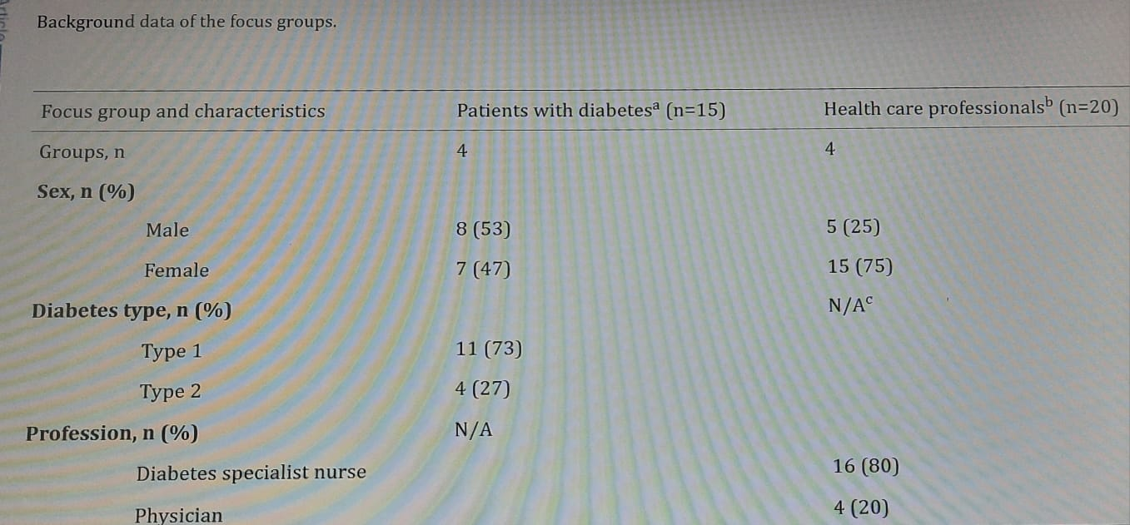

A total of 8 focus groups were conducted. Of these, 50% (4/8) were conducted with adult patients living with either type 1 or type 2 diabetes and 50% (4/8) were conducted with HCPs. Background data are presented in table. In accordance with the implementation strategy and study follow-up time of 12 months, both patients and HCPs had acquired initial experience in using the Diabetes Questionnaire. At the time of the focus group discussions, all HCPs had sent invitations to patients to answer the questionnaire and had discussed the answers with patients more than once. Most of the participating HCPs had undertaken several such conversations with different patients, but the number of conversations differed between the HCPs. As anticipated, the participating patients answered only 1 questionnaire since being invited to participate in this study, because routine clinical visits occur only once or a few times in a year. All patients except 1 (14/15, 93%) were given the opportunity to answer the Diabetes Questionnaire on 1 occasion. All patients who answered the questionnaire followed up the answers with their nurse or physician, some during clinical visits and some by telephone.
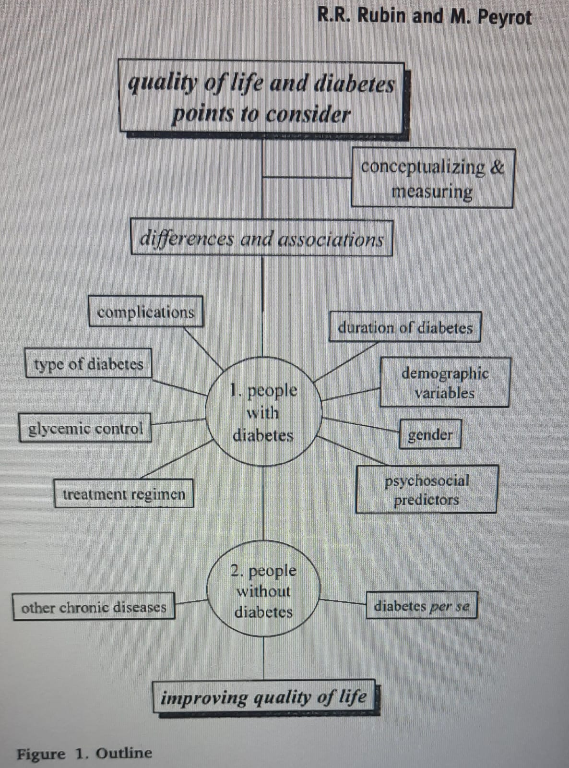

One major methodological issue has not been addressed by this survey. It is unclear whether several of the factors examined affect quality of life through objective physical health or through subjective perceptions. For example, any specific aged group affected by any certain complication and moving the capacity of these patients to cope may reverse the valence of this feedback loop from negative to positive.
Physical health of diabetes may energy and fatigue, impact of diabetes on feeling of full of energy or feeling tired. Physical strength impacts the ability to sustain prolonged physical or mental effort and pain and effect the quality of sleep which leads to feelings of mental distress which impact on mood states and attitudes sometimes emotional response to sickness, capacity to react to diabetes related negative or positive. Social health and life beliefs impact of diabetes on existing relationship with family and close friends even impact on sexual life. Diabetes impact on work, duties, and daily routines. In diabetes patients some time social environment, financial situation and on out-of-pocket expense due to excessive cost of medicine which may cause of mental stress. Some psychosocial factors, including health-related beliefs, social support, coping style and personality type, may powerfully affect quality of life, either directly or via their capacity to buffer the negative effects of diabetes or its management. In fact, these factors may predict quality of life more powerfully than important disease-related variables such as complications. Future research should control for or explicitly assess the effects of multiple factors and not simply ignore them or treat them as an undesirable source of variance.
In conclusion, Diabetes is a chronic, metabolic disease characterized by elevated levels of blood glucose (or blood sugar), which leads over time to serious damage to the heart, blood vessels, eyes, kidneys, and nerves. Quality of life plays major role in diabetes patients. There are many complications like physical, mental and health problems but, it can be managed by making and eat healthy food, be active most day, test blood sugar level often, take medicines as prescribed even if feel good. There are many basic care for diabetes like, make and eat healthy food, be active most day, test blood sugar, cope with the emotional side of diabetes, learn ways to manage stress, and go to checkup. Diabetes can be managed by good care and reduce chances of getting other chronic diseases and by advance Medicare facilities it can be increase quality of life and well-being.

References
- Eger RJ, Maridal JH. A statistical meta-analysis of the wellbeing literature. Int J Wellbeing. 2015. June 21;5(2) 10.5502/ijw.v5i2.4 - DOI
- Cho NH, Shaw JE, Karuranga S, Huang Y, da Rocha Fernandes JD, Ohlrogge AW, et al. IDF Diabetes Atlas: Global estimates of diabetes prevalence for 2017 and projections for 2045. Diabetes Res Clin Pract. 2018. April;138:271–81. 10.1016/j.diabres.2018.02.023 - DOI - PubMed
- Stevanović R, Capak K, Benjak T. CROATIAN HEALTH STATISTICS YEARBOOK 2019. Croatian Institute of Public Health; 2020 Sep. Cited 2021 Jun 25. Available from: https://www.hzjz.hr/wp-content/uploads/2021/02/Ljetopis_Yerabook_2019.pdf
- Policano T. Uloga praćenja dijabetičkih bolesnika pomoću registra CroDiab u prevenciji komplikacija. 2010.
- Mehović S, Janković S, Tafi Z. Quality of Life Assessment in Type 2 Diabetes Patients With Cardiovascular and/or Diabetic Complications. Southeastern European Medical Journal: SEEMEDJ. 2021;5(1):75–88.
- Jannoo Z, Wah YB, Lazim AM, Hassali MA. Examining diabetes distress, medication adherence, diabetes self-care activities, diabetes-specific quality of life and health-related quality of life among type 2 diabetes mellitus patients. J Clin Transl Endocrinol. 2017. September 1;9:48–54. 10.1016/j.jcte.2017.07.003 - DOI - PMC - PubMed
- Malmo OO, Nwozichi C. Clinical Predictors of Health-Related Quality of Life Among Patients with Type-2 Diabetes Mellitus at Federal Medical Centre Abeokuta. 2021; Available from: https://www.cjar.eu/wp-content/uploads/2021/05/2.5-2021-5-Clinical-Predi...
- Poljicanin T, Ajduković D, Sekerija M, Pibernik-Okanović M, Metelko Z, Vuletić Mavrinac G. Diabetes mellitus and hypertension have comparable adverse effects on health-related quality of life. BMC Public Health. 2010. January 13;10:12. 10.1186/1471-2458-10-12 - DOI - PMC - PubMed
- Dermanovic Dobrota V, Hrabac P, Skegro D, Smiljanic R, Dobrota S, Prkacin I, et al. The impact of neuropathic pain and other comorbidities on the quality of life in patients with diabetes. Health Qual Life Outcomes. 2014. December 3;12(1):171. 10.1186/s12955-014-0171-7 - DOI - PMC - PubMed
- Pibernik-Okanović M, Szabo S, Metelko Ž. Quality of life in diabetic, otherwise ill and healthy persons. Abstracts. in: Diabetes research and clinical practice 50 (2000)(S1). 2000;S235.
- Skevington SM, Lotfy M, O’Connell KA. The World Health Organization’s WHOQOL-BREF quality of life assessment: psychometric properties and results of the international field trial. A report from the WHOQOL group. Qual Life Res. 2004. March;13(2):299–310. 10.1023/B:QURE.0000018486.91360.00 - DOI - PubMed
- Pibernik-Okanović M. Psychometric properties of the World Health Organisation quality of life questionnaire (WHOQOL-100) in diabetic patients in Croatia. Diabetes Res Clin Pract. 2001. February 1;51(2):133–43. 10.1016/S0168-8227(00)00230-8 - DOI - PubMed
- Zoungas S, Woodward M, Li Q, Cooper ME, Hamet P, Harrap S, et al. Impact of age, age at diagnosis and duration of diabetes on the risk of macrovascular and microvascular complications and death in type 2 diabetes. Diabetologia. 2014. December;57(12):2465–74. 10.1007/s00125-014-3369-7 - DOI - PubMed
- Porta M, Curletto G, Cipullo D, Rigault de la Longrais R, Trento M, Passera P, et al. Estimating the delay between onset and diagnosis of type 2 diabetes from the time course of retinopathy prevalence. Diabetes Care. 2014. June;37(6):1668–74. 10.2337/dc13-2101 - DOI - PubMed
- Bonora E, Trombetta M, Dauriz M, Travia D, Cacciatori V, Brangani C, et al. Chronic complications in patients with newly diagnosed type 2 diabetes: prevalence and related metabolic and clinical features: the Verona Newly Diagnosed Type 2 Diabetes Study (VNDS) 9. BMJ Open Diabetes Res Care. 2020;8(1):e001549. 10.1136/bmjdrc-2020-001549 - DOI - PMC - PubMed
- Poljičanin T, Šekerija M, Metelko Ž. Šećerna bolest – epidemiološko stanje i javnozdravstvene aktivnosti u Hrvatskoj. Hrvatski časopis za javno zdravstvo. 2011;7(28). Available from: https://www.bib.irb.hr/529581?rad=529581
- Clotet S, Riera M, Pascual J, Soler MJ. RAS and sex differences in diabetic nephropathy. Am J Physiol Renal Physiol. 2016. May;310(10):F945–57. 10.1152/ajprenal.00292.2015 - DOI - PubMed
- Fan L, Wu X-J. Sex difference for the risk of amputation in diabetic patients: A systematic review and meta-analysis. PLoS One. 2021. March 11;16(3):e0243797. 10.1371/journal.pone.0243797 - DOI - PMC - PubMed
- Poljičanin T, Pavlić-Renar I, Metelko Ž, Coce F. Draft program of prevention of diabetic foot development and lower extremity amputation in persons with diabetes mellitus. Diabetol Croat. 2005;34(2):43–9.
- Metelko Z, Pavlić-Renar I, Poljicanin T, Szirovitza L, Turek S. Prevalence of diabetes mellitus in Croatia. Diabetes Res Clin Pract. 2008. August;81(2):263–7. 10.1016/j.diabres.2008.04.016 - DOI - PubMed
- Deshpande AD, Harris-Hayes M, Schootman M. Epidemiology of diabetes and diabetes-related complications. Phys Ther. 2008. November;88(11):1254–64. 10.2522/ptj.20080020 - DOI - PMC - PubMed
- Poljičanin T, Švajda M. National Diabetes Registry CroDiab: Report for 2019. Croatian Institute of Public Health; 2020. Available from: https://www.hzjz.hr/wp-content/uploads/2020/03/Izvje%C5%A1%C4%87e-za-201...
- Kawasaki R, Tanaka S, Tanaka S, Yamamoto T, Sone H, Ohashi Y, et al. Incidence and progression of diabetic retinopathy in Japanese adults with type 2 diabetes: 8 year follow-up study of the Japan Diabetes Complications Study (JDCS). Diabetologia. 2011. September;54(9):2288–94. 10.1007/s00125-011-2199-0 - DOI - PubMed
- Popescu S, Timar B, Baderca F, Simu M, Diaconu L, Velea I, et al. Age as an independent factor for the development of neuropathy in diabetic patients. Clin Interv Aging. 2016. March 15;11:313–8. - PMC - PubMed
- Rossaneis MA. Haddad M do CFL, Mantovani M de F, Marcon SS, Pissinati P de SC. Foot ulceration in patients with diabetes: a risk analysis. Br J Nurs. 2017. March 23;26(6):S6–14. 10.12968/bjon.2017.26.6.S6 - DOI - PubMed
- Lane KL, Abusamaan MS, Voss BF, Thurber EG, Al-Hajri N, Gopakumar S, et al. Glycemic control, and diabetic foot ulcer outcomes: A systematic review and meta-analysis of observational studies. J Diabetes Complications. 2020. October 1;34(10):107638. 10.1016/j.jdiacomp.2020.107638 - DOI - PMC - PubMed

